BANA
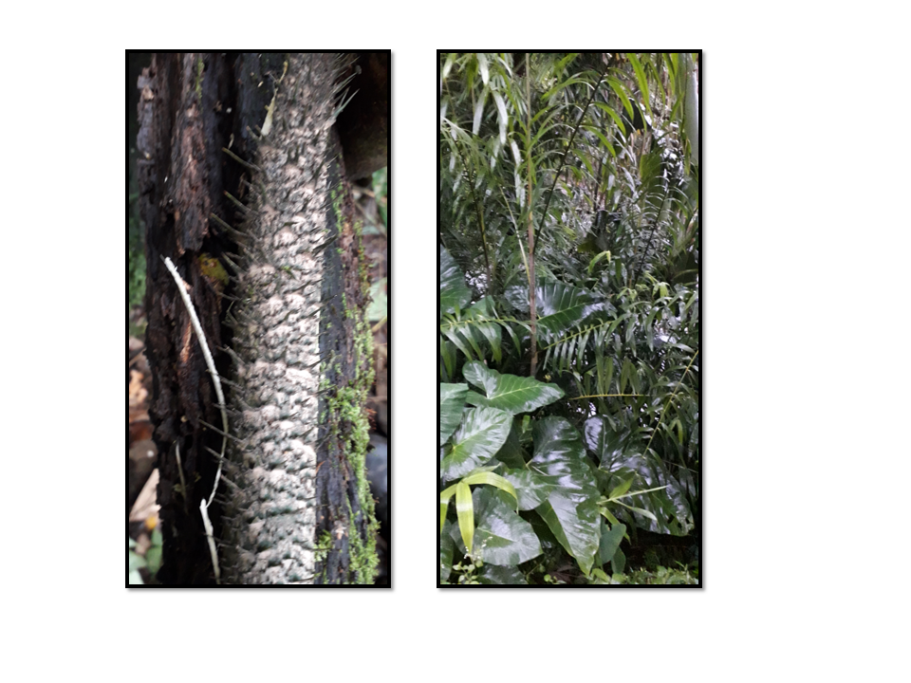
Non-Wood Forest Products Management and Marketing Group
Lajab Gewog, Dagana Dzongkhag
Plan Period: August 2022-July 2027

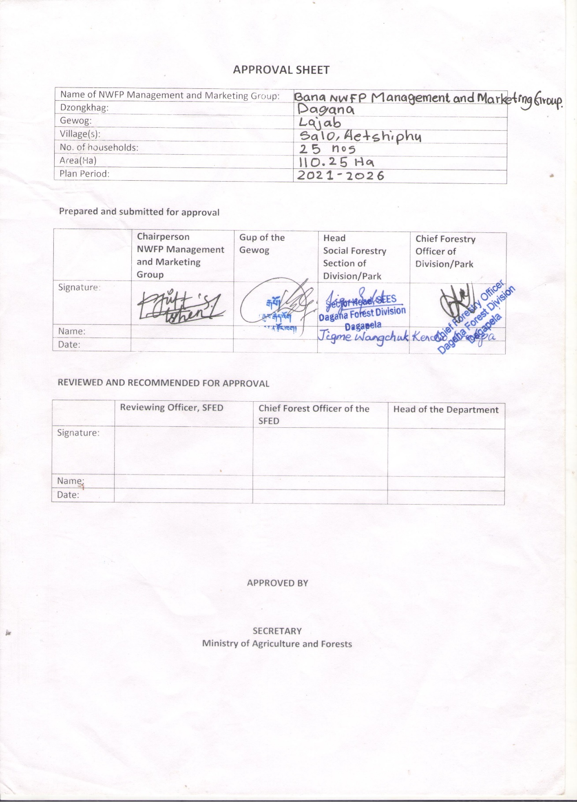
Approval sheet
Contents

Approval sheet i
Part A: NWFP Management and Marketing Plan 4
1. Background 4
1.1. Goals and Objectives 4
1.2. Description of the NWFPs 5
2. Harvesting prescription for sustainable harvesting of Plectocomia himalayana 6
3. The NWFP Collection Area 7
4. Marketing and Sales Plan 7
5. Marketing arrangement 8
6. Benefits to members 8
7. Cane Resource assessment 9
8. Analysis of Resource Assessment Data 9
9. Annual Harvesting Limits 9
a. Cane population and annual harvesting limit of block I 10
b. Annual Harvesting Limits of Canes from block II 11
c. Annual Harvesting Limits of Canes from block III 12
PART B: By-Laws: Group Regulations and Norms 13
10. Members of the NWFP management & marketing group 13
10.1 Responsibilities and rights of members 13
11. Executive committee 13
11.1. Chairperson 13
11.1.1 Responsibilities of Chairperson 13
11.2. Secretary 14
11.2.1 Responsibilities of Secretary 14
11.3. Treasurer 14
11.3.1 Responsibilities of Treasurer 14
12. Compensation for executive Committee members 15
13. Membership Fee and purpose 15
14. Community development fund and utilization of fund 15
15. Conflict Resolution 15
16. Penalties 16
17. Authority of the Department 16
Annexure I: Membership list 17
Annexure II: Block description form for canes 19
Annexure III: Data Compilation Sheet 22
Annexure IV: Application for the establishment of NWFP group from Gewog Administration 29

Part A: NWFP Management and Marketing Plan

1. Background
The Bana Chiwog is located at the heart of Lajab Gewog under Dagana Dzongkhag. The Chiwog has 52 household of Salo and Aetshiphu with ethnicity of Lhotshompas, Sharshops and Ngalops. The people in the village grow vegetables, maize, paddy to meet annual household food requirement and cardamom as cash crop. With support from agriculture sector, they also practice modern farming - use of greenhouse and also installed electric fencing to protect their crops from wild animal. They also rear cattle such as cow, oxen and goat, which serve as source of the diary product, meat and oxen to plough field despite having farm machinery such as power-tiller.

The Gewog, being located on the fringes of the Cool-broadleaved forests, which has a rich biodiversity of the flora and fauna. It favours the growth of high economic valued trees such as walnut and kimbu. Also various animals such as barking deer and Himalayan black bear are also found in the forest. Besides that, non-wood forest products (NWFP) such as Elatosteme lineolatum Zanthoxylum armatum, Persia fruitifera, Diplazium esculentum, bamboos (Chimonobambusa callosa, Dendrocalamus hamiltonii and Himalayanacalamus hookerinus) and Plectocomia himalayana are found and being collected by community for self-consumption and also for sale. They depend on cane (Plectocomia himalayana) mainly for baskets making and other useful household utilitarian products. Cane shoots are mainly used as food during the gathering and other important events such as marriage and other related celebrations.

Currently the cane resources from the area are collected based on permit system. However, it is not managed properly as there are over exploitation as an ownership is still hold by the government. The formation of the management group would enable handing over of management responsibilities to the community and reduce overharvesting and over exploitation of the resources. Such initiative is likely to increase income generation and employment opportunities for the end users. With control gained over the area, the group can also planned for increasing cane stock through plantation in the feasible area. Based on cane assessment result, the group can harvest 2326 numbers of matured canes 1238 numbers of shoots in a year. The resources growing areas were located after the prior consultation conducted with group.

1.1. Goals and Objectives
1. Sustainable harvesting of matured cane and cane shoots.
2. To develop marking chain for cane resources. And products
3. Product diversification through skill development program to members.

1.2. Description of the NWFPs
The region harbors growth of variety of Non-Wood Forest Products such as Elatostema lineolatum, mushrooms, Zanthoxylum armatum, various bamboos, wild avocado, various fern species, and cane; most abundantly Plectocomia himalayana, which is also known as the Patsa(Dz), Phasey (Sharshop) and Phakeri beet (Lh) that has the distribution range from 1200 m above sea level to 2150 m above the sea level.
During the peak harvesting season, the NWFP of the area are harvested for local consumption as well as for commercial purpose which are sold in Thimphu market by the local vendor directly. Some species of Bamboos such as Chimnobambusa callosa, Dendrocalamus hamiltonii and Himalayacalamus hookerinus are harvested for fencing, and for making various households products which has daily usage.
The shoot portion of the cane species are used as the source of food during some of the important occasions such as marriage party, Londa and other occasional gatherings. However, the matured cane parts are used for the production of baskets and various kitchen utensils.
Table01.Brief description of NWFPs for commercial harvesting
NWFP Name | Harvesting Area | Parts harvested | Uses or Purposes(traditional& others) | Harvesting season (month) | Estimated quantity that can be collected
Plectocomia himalayana  (Canes) | Pakhaychok, Sukaypokri, Aetshilum, Dorona and Lalichok | Young Shoots & Matured Canes | Shoots used as cuisine (patsajaju)  Matured canes for the handicrafts | Winter for the Handicraft purpose  Summer for cane shoots | 2820Nos  1630Nos

2. Harvesting prescription for sustainable harvesting of Plectocomia himalayana
Scientific Name | Prescription for sustainable harvesting of cane and shoot
Plectocomia himalayana | Collection of matured cane:  - Harvest during winter as canes have a better quality during this season  - Pull down as much of the stem as possible(avoid leaving cane parts high up in the tree)  - Cut only canes with a usable length of at least 10m.  - Trees supporting the canes shall not be felled
For cane shoots:
- Cut young shoots by bending the cane stem with the help of a long and strong stick with a hook.
- Do not cut the entire cane to collect the shoots. Cut the leading shoot with a sharp knife diagonally (not straight in order to avoid rotting of the remaining stump); leave lateral shoots.
- Care shall be taken to avoid damaging sucker buds (these will later develop into lateral shoots).
- Harvest only shoots identified for collection during plan (year1 to 4 years)

3. The NWFP Collection Area
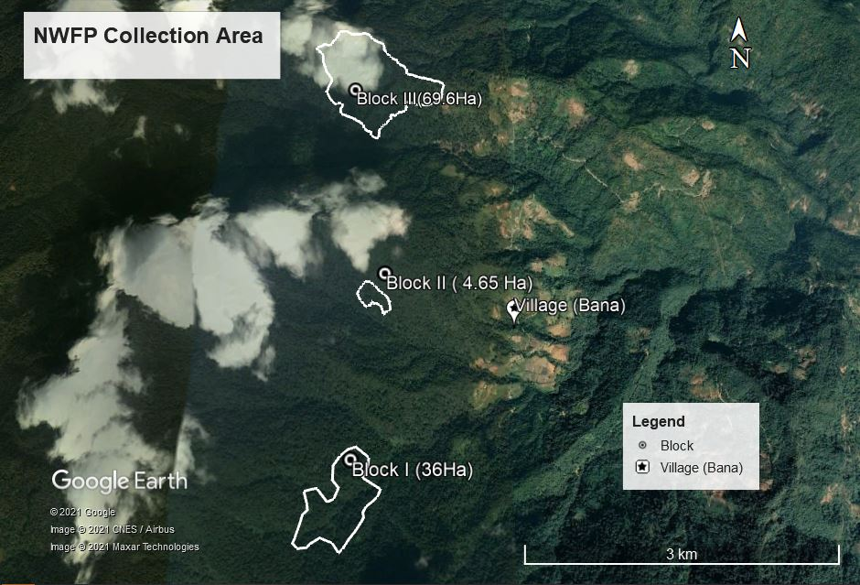
Below is the map of the NWFP collection area of the Bana Chiwog, which is divided into three blocks. The farthest collection area is located at three hours distance from the village.

4. Marketing and Sales Plan
The cane products will be sold in two forms; 1) Shoots and handicraft. The potential markets for the sale of the canes shoots and its products are Thimphu, Wangdue, Dagana and Tsirang. Shoots will be collected from open patches where cane hasn’t climbed on trees. Also it will be collected from cut canes. The handicraft will be produced from matured cane. It will be produced and sold from handicraft house constructed at the Gewog center recently.
The collection and sell of products will take place only after convent of general meeting. The group shall discuss each year’s collection timing of cane shoot and matured cane and also finalize group’s middlemen. The market for the product will be sought by middlemen identified from the group. He will arrange the transportation and deposit royalty amount paid to the forest office and other agreed amount to the group account before lifting the products. The quantity of the sales to the specific location shall be as per the demand and if incase lots of demand comes, and then it shall be divided among them. Quantity of cane shoot and matured cane to be collected in plan period and income estimated is given in table 02.
Table 2. Marketing and Sales Plan
NWFP | Potential  Market | Estimated quantity for sale per season (unit) | Expected price per unit | Total (Nu.) | Remarks
Cane shoots (Plectocomia himalayana) | In-country, mostly Thimphu and Wangdue | 2820 | Nu.30/unit to members | 84600.00 | Deposit 5% of the sales proceeds to group account.
Canes (Plectocomia himalayana) | In-country, mostly Thimphu and Wangdue | 1630 | Nu.100/unit | 163000/- | Deposit 5% of the sales proceeds to group account.
Total Amount |  |  |  | Nu.247,600/-
Note: The Price of the product shall be fixed from time to time as per meeting when selling to outsiders after receiving an order.

5. Marketing arrangement
The main market shall be Thimphu, Wangdue, Tsirang and Dagana. The group will collect NWFPs resources on order basis. Based on product demand, the chairperson will obtain collection permit from the forest office.

6. Benefits to members
- The members registered in the group shall have the equal right for the collection and marketing of the NWFP as per the guidelines of the Management group.
- Each member has right to get equal share from the accumulated group fund.
- The resources of cane shall be equally divided among the group.

7. Cane Resource assessment
The cane resource assessment was done with the help of the QGIS. The sampling intensity used was 5% or more. The area was first demarcated after the consultation with the user group with the help of the GPS device in the real field, which was later converted into shape file in the QGIS.
The shape file was then inserted in the Q-GIS and the plotting was done. The regular plots were plotted using sampling intensity of 5% or more. The plots were then again inserted into the GPS device for the resource assessment.

8. Analysis of Resource Assessment Data
The data collected in the field was analyzed using the excel sheet where the data of the canes in the different sizes are entered into the different column. After entering the data, area of the total sample plot is drawn. Then the total canes or shoots of the different class or group was then drawn, which was further divided into each sample plots where the data are extrapolated and then the annual harvesting limit of each sample class was drawn.

9. Annual Harvesting Limits
Mature cane category shall be collected based on the harvesting limit set in the management and marketing plan from three blocks. Here the matured cane means cane stem harvestable during survey period and those cane stem which will get matured and cane be harvested during the plan period (5years). An annual harvesting limit of cane in a block has been calculated assuming that it would take 10 years to get usable cane length of 10meters. However, during harvest it shall be taken into consideration that semi-mature canes will only be harvested only towards end of the plan period. Semi mature category of the canes growing on open areas shall be harvested for the shoots during plan period. Under any circumstances, immature canes stems climbing on trees will not be harvested for shoot. The suckers and the cane category of the semi-mature and immature shall be left for the growing that shall replace the one that are harvested. For shoots five years was estimated as its rotation period. In this plan an annual harvesting limit was not calculated sucker as we cannot determine survival of suckers growing in the block.

Cane population and annual harvesting limit of block I
Block Area in acres/Ha = 36 Ha/ 88.96 Acres
Total sample area covered in block(acres) = (no of sample plots in block x sample plot size)/10,000 = (34 plots x 500.34 m²)/10,000 = (1.701156 x 2.471) = 4.20 Acres
No. of sample plots to be accommodated in block=Block area/total sample area(88.96/4.20=21.18 ( c )
Time period for harvesting canes for handicrafts/cane shoots | Cane species | Cane count in all sample plot (a) | Total cane stock in (c) = (a) x (b) | AHL of from the block  Cane=(c/10)  Shoot=(c/5)
Mature Canes  Year 1-2 (L>20m (Cane > 10m) | Plectocomia  himalayana | 64 | 1355.52 | 136
Semi-Mature  Year 3-4 (>20m (cane<10m) Length (Canes) | Plectocomia  himalayana | 41 | 868.38 | 87
Semi-Mature  Year 3-4 (>20m (cane<10m) Length (Shoots) | Plectocomia  himalayana | 48 | 1016.64 | 203
Immature  Year 5-6 (10-20m) (Canes) | Plectocomia  himalayana | 21 | 444.78 | 41
Immature  Year 5-6 (10-20m) (Shoots) | Plectocomia  himalayana | 30 | 635.40 | 127
Immature  Year 7-8(2-<10m Length) (canes) | Plectocomia  himalayana | 23 | 487.14 | 49
Immature  Year 7-8(2-<10m Length) (Shoots) | Plectocomia  himalayana | 50 | 1059 | 212
Suckers  Year 9-10 (Present<2m) | Plectocomia  himalayana | 148 | 3134.64 | Nil

Annual Harvesting Limits of Canes from block II
Block Area in acres/Ha = 4.65 Ha/ 11.5 Acres
Total sample area covered in block(acres) = (no of sample plots in block x sample plot size)/10,000 = (5 plots x 500.34 m²)/10,000 = (0.25017 x 2.471) = 0.61817 Acres (b)
No. of sample plots to be accommodated in block=Block area/total sample area(11.5/0.61817=19 ( c )
Population structure in Cane in a block | Cane species | No. of canes in sampled area (d) | Total cane stems in block (e )= d x c | AHL from the block  Cane=e/10  Shoot=e/5
Mature Canes  Year 1-2 (L>20m (Cane > 10m) | Plectocomia  himalayana | 59 | 1121 | 112
Semi-Mature  Year 3-4 (L>20m (cane<10m) Length (Canes) | Plectocomia  himalayana | 32 | 608 | 61
Semi-Mature  Year 3-4 (L>20m (cane<10m) Length (Shoots) | Plectocomia  himalayana | 33 | 627 | 125
Immature  Year 5-6 (10-20m) (Canes) | Plectocomia  himalayana | 10 | 190 | 19
Immature  Year 5-6 (10-20m) (Shoots) | Plectocomia  himalayana | 9 | 171 | 34
Immature  Year 7-8(2-<10m Length) (canes) | Plectocomia  himalayana | 23 | 437 | 44
Immature  Year 7-8(2-<10m Length) (Shoots) | Plectocomia  himalayana | 27 | 513 | 102
Suckers  Year 9-10 (Present<2m) | Plectocomia  himalayana | 113 | 2147 | Nil

Annual Harvesting Limits of Canes from block III
Block Area in acres/Ha = 69.6 Ha/ 172.73 Acres (a)
Total sample area covered in block (acres) = (no of sample plots in block x sample plot size)/10,000 = (69 plots x 500.34 m²)/10,000 = (3.452346 x 2.471) = 8.530749 Acres ( b)
No. of sample plots to be accommodated in block=Block area/total sample area(172.73/8.530749=20.25 ( c )
Time period for harvesting canes for handicrafts/cane shoots | Cane species | No. of canes in sampling area (d) | Total cane in block (e)=  (c x d) | AHL from the block  Cane = e/ 10 years  Shoot= e/ 5 years
Mature Canes  Year 1-2 (L>20m (Cane > 10m) | Plectocomia  himalayana | 583 | 11806 | 1181
Semi-Mature  Year 3-4 (>20m (cane<10m) Length (Canes) | Plectocomia  himalayana | 261 | 5285 | 53
Semi-Mature  Year 3-4 (>20m (cane<10m) Length (Shoots) | Plectocomiahimalayana | 213 | 4313 | 862
Immature  Year 5-6 (10-20m) (Canes) | Plectocomia  himalayana | 86 | 1742 | 17
Immature  Year 5-6 (10-20m) (Shoots) | Plectocomiahimalayana | 278 | 5629 | 1125
Immature  Year 7-8(2-<10m Length) (canes) | Plectocomia  himalayana | 38 | 770 | 8
Immature  Year 7-8(2-<10m Length) (Shoots) | Plectocomia  himalayana | 295 | 5974 | 1194
Suckers  Year 9-10 (Present<2m) | Plectocomia  himalayana | 148 | 2997 | Nil

PART B: By-Laws: Group Regulations and Norms

 | Village | Number of member households | Gewog
 | Salo, Aetshiphu | 25 | Lajab
10. Members of the NWFP management & marketing group | 10.1 Responsibilities and rights of members  - Every household with definite Gung and Thram from Bana Chiwog are eligible to become a member of NWFP Management Group.  - Each member will contribute a sum of Nu.100 (one hundred) only as annual membership fee in the month of January every year.  - Any new member willing to join the group from the same Gung shall join so with realisation of the normal annual membership fees.  - Any members withdrawing from the membership shall not be eligible to claim any benefits and NWFPs resources collection from the Management area unless it is a genuine case (illness or famine). Member’s withdrawal on genuine ground shall be verified and if found genuine shall have right to claim 50% of his share from the group.  - During the time when new non-members want to join a short meeting shall be held for the necessary verification.  10.2 Responsibilities of members:  - Actively participate in general assembly to be held once in a year.  - Collect NWFPs and inform/hand over to committee for proper record and marketing.  - Support the chairperson and committee members to protect the resources from illegal activities.  - Ensure sustainable harvesting of NWFPs resources.

11. Executive committee
11.1. Chairperson | Name of Chairperson: Kinley Gyeltshen

11.1.1 Responsibilities of Chairperson
- Chair the meeting related to NWFPs management, utilization and marketing.
- Work in close coordination with other current prevailing Organizations, sectors and agencies, and seek assistance for the development of management group.
- To obtain permit for the sale of group’s/individual’s handicraft items and other NWFPs from CFO.
- Represent the group in meetings that will take place in other parts of the country and share new information and ideas acquired from the meeting with the group members on his return.
- Resolve disputes and conflicts arising among the group members and maintain good working relations.
- Coordinate the patrolling from time to time involving the members.
- Initiate annual planning with committee members and present to the group members during general assembly.
- Jointly sign with the Secretary and Treasurer on the cheque during the withdrawal of community fund.
11.2. Secretary | Name of Secretary: Joti Lal Gurung

11.2.1 Responsibilities of Secretary
- Officiate as chairperson.
- Inform the date, time and venue of meeting to all the group members.
- Keep minutes of NWFPs related meetings and make presentation at the end.
- Assist the chairperson in solving conflicts arising among members and maintain good working relations, and also in marketing of NWFPs.
- Keep proper record and data of NWFPs collected and marketed.
- Jointly sign with the Chairperson and Treasurer on the cheque during the withdrawal of community fund.
- Prepare monthly/quarterly or annual progress report and submit to the CFO.
11.3. Treasurer | Name of Treasurer: HarkaBdr Gurung

11.3.1 Responsibilities of Treasurer
- Keep proper records and accountings of NWFPs and assist the chairperson and secretary in marketing.
- Issue a receipt to the individual for quantity of NWFPs collected for sale.
- Keep annual financial transaction records and present to the group members during the general assembly.
- Collect and deposit the money in the NWFPs group account maintained with the nearest financial institution.
- Jointly sign with the Chairperson and Secretary on the cheque during the withdrawal of community fund.
- Prepare financial report and submit to the CFO as and when asked.
12. Compensation for executive Committee members | The committee members will serve for five years without any incentives. But if there are opportunities for trainings from the Government and other agencies, priority will be given to them as an incentive. It will be given on turn wise basis, if it is not work specific.
13. Membership Fee and purpose | Every member shall contribute annual membership fee of Nu. 100 (hundred) only. The amount will be deposited in the nearest bank and utilized the accumulated amount for the welfare of the NWFPs group members in the near future. The collect amount shall be used in case in any meeting or other activities of the group.
14. Community development fund and utilization of fund | The community development fund will be generated through deduction of certain percentage from the sale amount of NWFPs and handicraft items.  - For handicraft items, the deduction will be 10% of the total amount earned from each individual or as a whole after the marketing or sale of products annually.  - The fund shall be utilized for the welfare of NWFPs group members only.  - During emergencies (death), natural calamities etc, not more than 5% of amount will be given to the victim as “semso” upon discussion/meeting with the community.  In case of utilization of the fund, a small discussion/meeting shall be held and the utilization of the fund shall be approved which shall then be used and later the bill/memo shall be presented to the group in the annual meeting.
15. Conflict Resolution | - The chairperson and executive committee members shall resolve the conflict arising among the group members.  - If the conflict arises between executive committee members and the group members, the matter shall be forwarded to Gewog administration and Range office, which if unable to solve shall further be forwarded to the Prevailing Higher Authority( Court)  - If the problem arises between group members and other communities, the matter shall directly forward to Gewog Administration for settlement, and if it is not resolved at Gewog level, matter shall be further forwarded to the Dzongkhag Administration.
16. Penalties | Collection or harvesting of NWFPs for rural consumption purposes will remain free of royalty while for the sale of NWFP (Cane and Cane Shoots) including handicraft items shall require permit from CFO.  Fines and penalties against the illegal activities within the Management area;  - NWFPs collection by him/her without the permission will be fined as per FNCRR, 2017, 2020 and 2021 and the products shall be seized.  - The fine should be paid off within 30(thirty days), in case, if failed, it shall be forwarded to Gewog Administration/Forest office/court or stopped him/her from availing the resources from the forest by the community through general assembly.  - Absent fees during meeting Nu.200  If a member of the NWFP Group violates the harvesting rules as set in this plan, he or she will not be allowed to harvest the NWFP anymore for the rest of the season and the following season.  If there is any offence that is not mentioned above, it shall be dealt as per the latest rules and regulation of the Department of Forests and Park Services.
17. Authority of the Department | As per Chapter III, section 155 of FNCRR, 2017, the Department shall:  - Suo moto or on the request by the Non-Wood Forest Management Group (NWFMG) take action against violator of the Act, Rules or Management Plan;  - Inspect, monitor, review the records of and otherwise supervise the activity of the NWFP Management Group; and  Take action including cancellation of the NWFP Management Group certificate if the NWFP-MG or any of its members who violate the provision of the Management Plan or any provision under this Chapter.

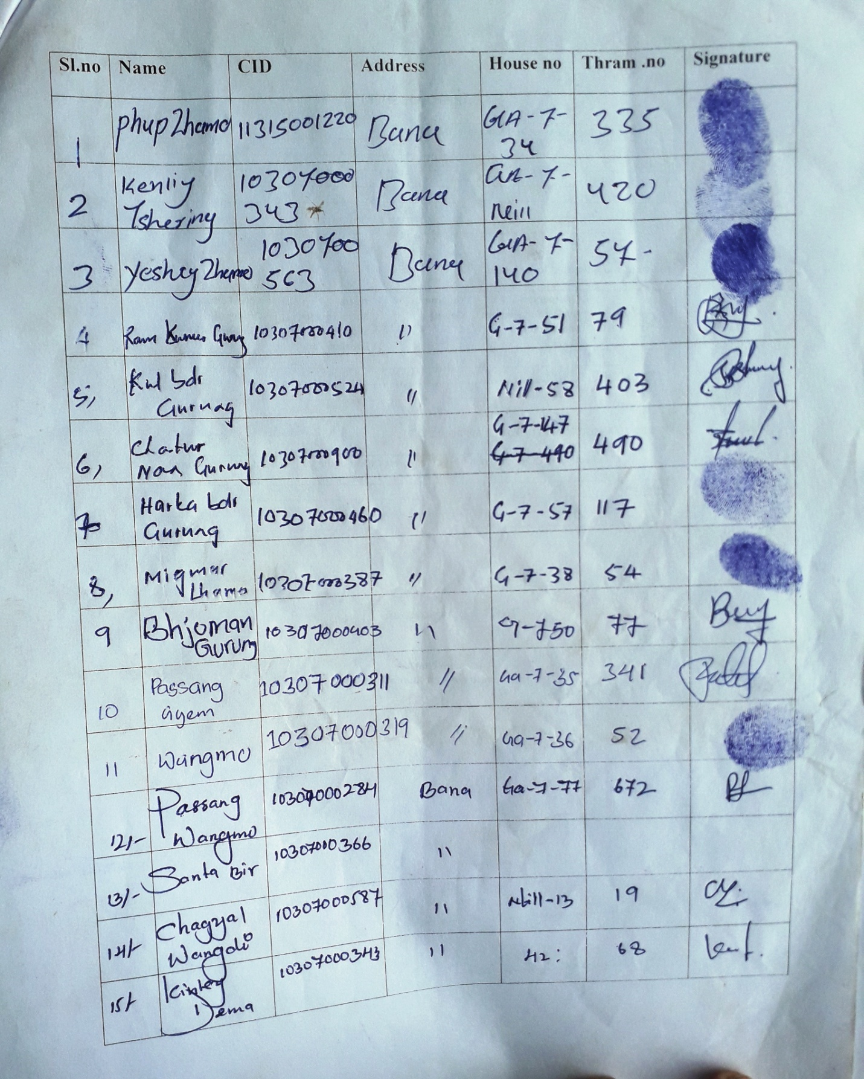
Annexure I: Membership list
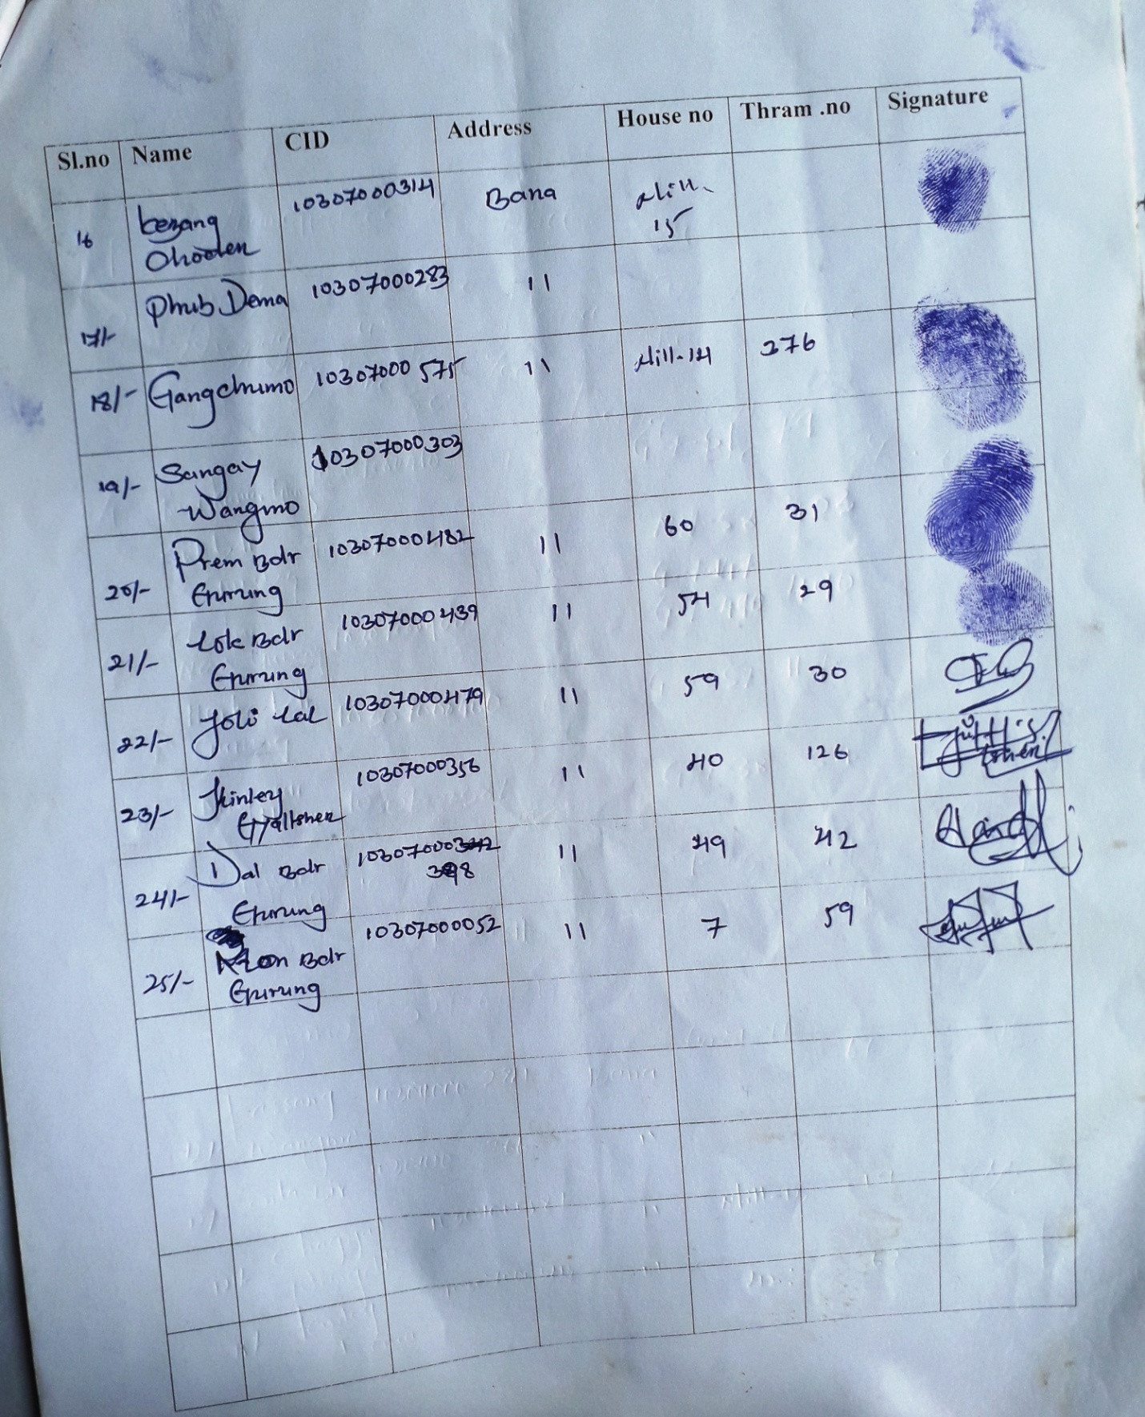

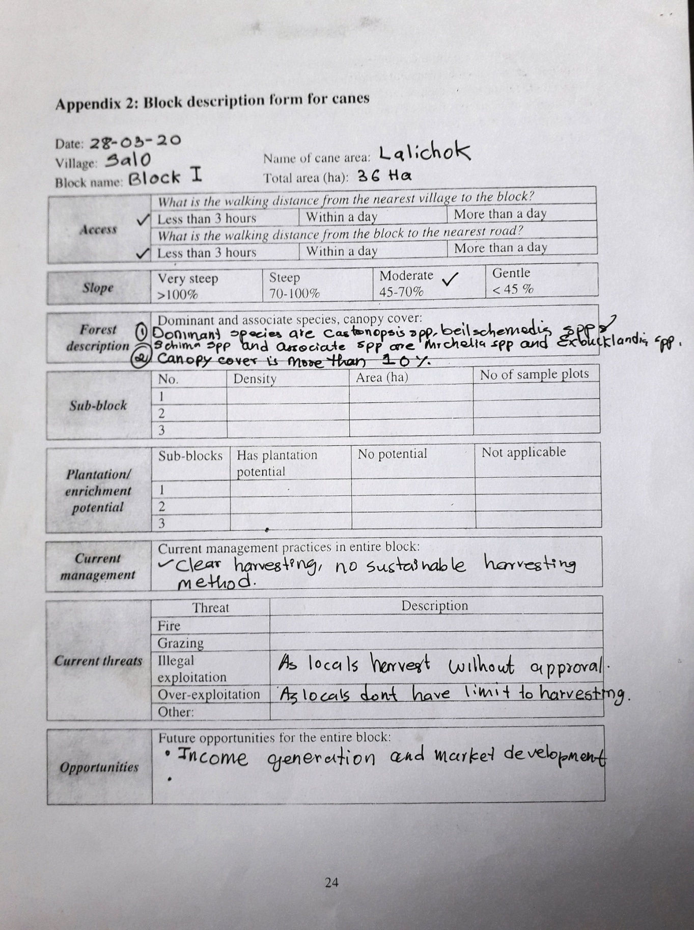
Annexure II: Block description form for canes
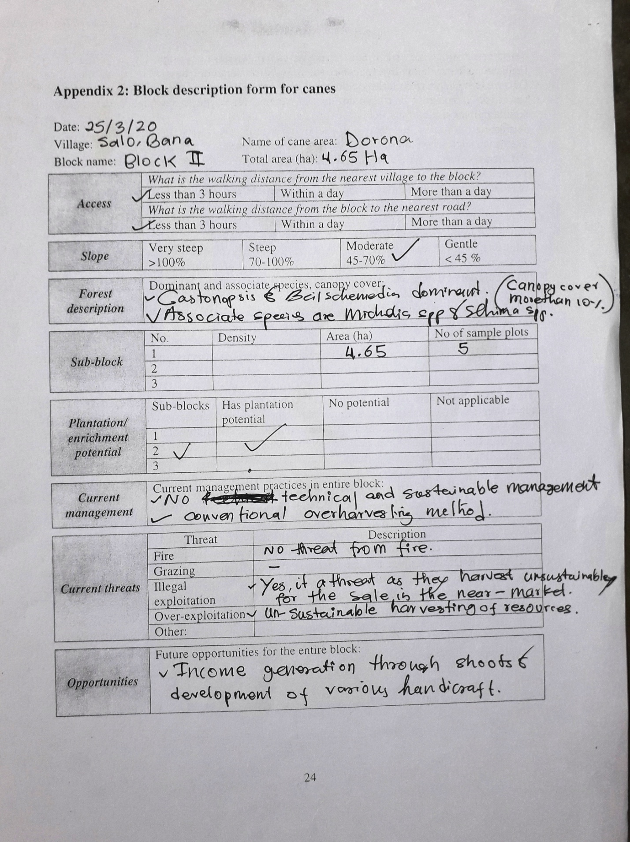
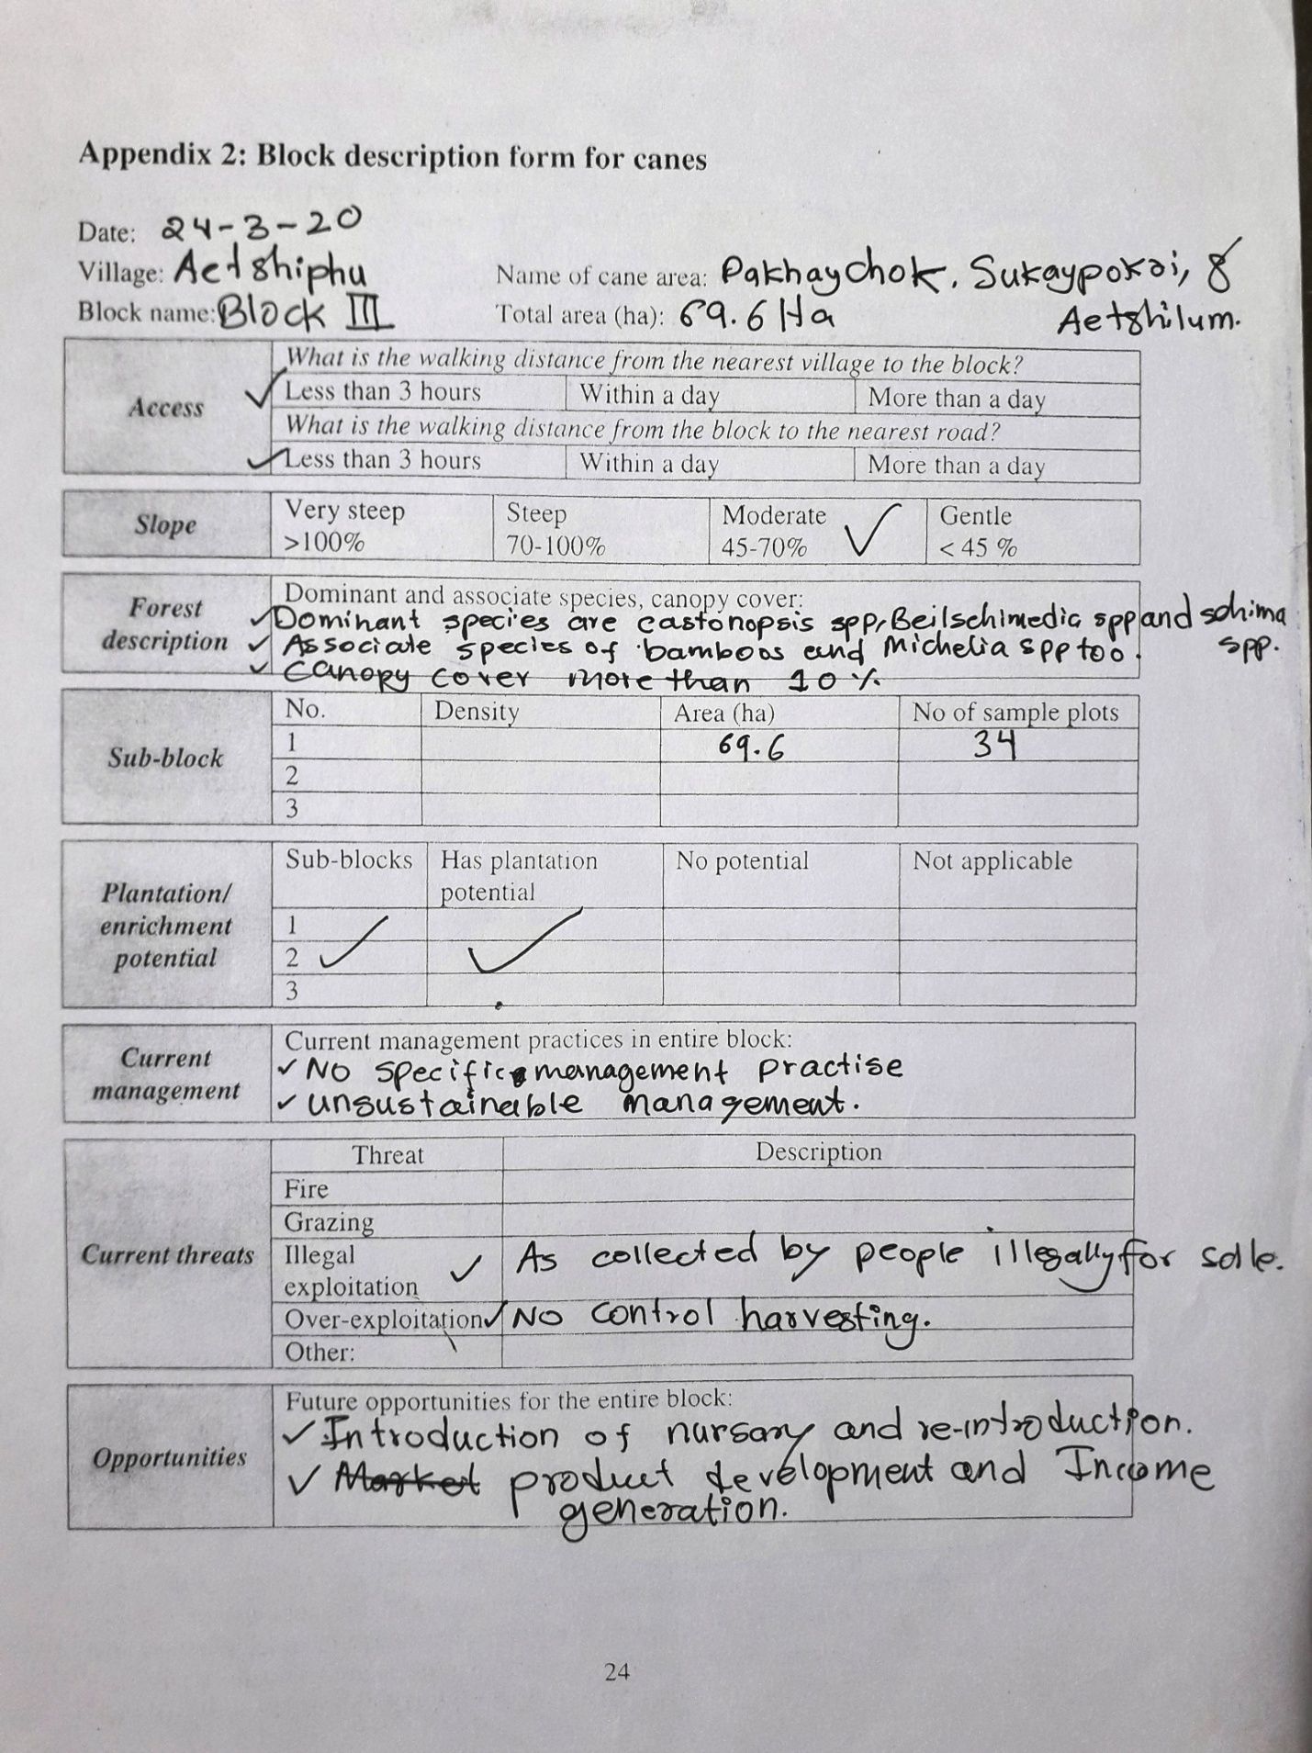

Annexure III: Data Compilation Sheet
Data Compilation for Block I
PlectocomiaHimalayana (Canes)
Plot no | <2m | 2-<10m | 10-20m | L>20m(Cane<10) | L>20m(Cane>10)
1 | 10 | 0 | 0 | 0 | 0
2 | 0 | 0 | 0 | 0 | 0
3 | 12 | 0 | 2 | 0 | 5
4 | 8 | 4 | 3 | 5 | 3
5 | 4 | 0 | 0 | 2 | 0
6 | 16 | 2 | 2 | 0 | 2
7 | 17 | 2 | 1 | 3 | 4
8 | 14 | 2 | 1 | 3 | 5
9 | 18 | 4 | 2 | 4 | 3
10 | 8 | 2 | 3 | 7 | 5
11 | 0 | 0 | 0 | 0 | 4
12 | 0 | 0 | 0 | 0 | 0
13 | 11 | 4 | 0 | 2 | 6
14 | 7 | 1 | 2 | 2 | 4
15 | 9 | 0 | 4 | 2 | 4
16 | 0 | 0 | 0 | 0 | 0
17 | 0 | 0 | 0 | 0 | 0
18 | 7 | 1 | 1 | 0 | 4
19 | 0 | 0 | 0 | 0 | 0
20 | 0 | 0 | 0 | 0 | 0
21 | 6 | 0 | 0 | 6 | 8
22 | 0 | 0 | 0 | 0 | 0
23 | 0 | 0 | 0 | 0 | 0
24 | 0 | 0 | 0 | 0 | 0
25 | 0 | 0 | 0 | 0 | 0
26 | 1 | 0 | 0 | 3 | 3
27 | 0 | 0 | 0 | 0 | 0
28 | 0 | 0 | 0 | 0 | 0
29 | 0 | 0 | 0 | 0 | 0
30 | 0 | 0 | 0 | 0 | 0
31 | 0 | 0 | 0 | 0 | 0
32 | 6 | 1 | 0 | 2 | 4
33 | 0 | 0 | 0 | 0 | 0
34 | 0 | 0 | 0 | 0 | 0
Total | 148 | 23 | 21 | 41 | 64
Data Compilation for Block I
Plectocomiahimalayana (Shoots)
Plot no | <2m | 2-<10m | 10-20m | L>20m(Cane<10) | L>20m(Cane>10)
1 | 0 | 0 | 0 | 0 | 0
2 | 0 | 0 | 0 | 0 | 0
3 | 0 | 0 | 2 | 3 | 0
4 | 0 | 4 | 2 | 4 | 0
5 | 0 | 0 | 0 | 0 | 0
6 | 0 | 3 | 1 | 0 | 0
7 | 0 | 4 | 2 | 3 | 0
8 | 0 | 2 | 1 | 4 | 0
9 | 0 | 5 | 2 | 3 | 0
10 | 0 | 3 | 5 | 3 | 0
11 | 0 | 0 | 3 | 2 | 0
12 | 0 | 0 | 0 | 0 | 0
13 | 0 | 8 | 1 | 13 | 0
14 | 0 | 5 | 2 | 0 | 0
15 | 0 | 4 | 2 | 2 | 0
16 | 0 | 0 | 0 | 0 | 0
17 | 0 | 0 | 0 | 0 | 0
18 | 0 | 0 | 3 | 1 | 0
19 | 0 | 0 | 0 | 0 | 0
20 | 0 | 0 | 0 | 0 | 0
21 | 0 | 6 | 4 | 0 | 0
22 | 0 | 0 | 0 | 0 | 0
23 | 0 | 0 | 0 | 0 | 0
24 | 0 | 0 | 0 | 0 | 0
25 | 0 | 0 | 0 | 0 | 0
26 | 0 | 1 | 0 | 0 | 0
27 | 0 | 0 | 0 | 0 | 0
28 | 0 | 0 | 0 | 0 | 0
29 | 0 | 0 | 0 | 0 | 0
30 | 0 | 0 | 0 | 0 | 0
31 | 0 | 0 | 0 | 0 | 0
32 | 0 | 5 | 0 | 10 | 0
33 | 0 | 0 | 0 | 0 | 0
34 | 0 | 0 | 0 | 0 | 0
Total | 0 | 50 | 30 | 48 | 0

Data Compilation for Block II
Plectocomiahimalayana (Canes)
Plot no | <2m | 2-<10m | 10-20m | L>20m(Cane<10) | L>20m(Cane>10)
1 | 27 | 2 | 1 | 6 | 7
2 | 24 | 7 | 8 | 11 | 7
3 | 18 | 11 | 0 | 6 | 9
4 | 25 | 3 | 1 | 5 | 17
5 | 19 | 0 | 0 | 4 | 19
Total | 113 | 23 | 10 | 32 | 59
Data Compilation for Block II
Plectocomiahimalayana (Shoots)
Plot no | <2m | 2-<10m | 10-20m | L>20m(Cane<10) | L>20m(Cane>10)
1 | 0 | 5 | 2 | 7 | 0
2 | 0 | 10 | 5 | 5 | 0
3 | 0 | 8 | 0 | 5 | 0
4 | 0 | 3 | 2 | 11 | 0
5 | 0 | 1 | 0 | 5 | 0
Total | 0 | 27 | 9 | 33 | 0

Data Compilation for Block III
Plectocomiahimalayana (Canes)
Plot no | <2m | 2-<10m | 10-20m | L>20m(Cane<10) | L>20m(Cane>10)
1 | 3 | 0 | 0 | 0 | 1
2 | 0 | 0 | 0 | 0 | 0
3 | 0 | 0 | 0 | 0 | 0
4 | 24 | 0 | 7 | 1 | 16
5 | 22 | 0 | 0 | 4 | 14
6 | 10 | 3 | 0 | 0 | 9
7 | 26 | 3 | 0 | 10 | 15
8 | 25 | 0 | 0 | 4 | 14
9 | 17 | 0 | 8 | 4 | 17
10 | 0 | 0 | 0 | 0 | 0
11 | 11 | 0 | 0 | 13 | 4
12 | 16 | 2 | 3 | 23 | 11
13 | 7 | 2 | 0 | 4 | 24
14 | 26 | 0 | 1 | 0 | 13
15 | 2 | 0 | 0 | 2 | 12
16 | 2 | 1 | 0 | 1 | 2
17 | 12 | 2 | 0 | 3 | 18
18 | 8 | 0 | 0 | 2 | 12
19 | 2 | 1 | 0 | 1 | 0
20 | 0 | 0 | 0 | 0 | 0
21 | 5 | 2 | 2 | 3 | 6
22 | 1 | 0 | 0 | 0 | 4
23 | 20 | 0 | 0 | 9 | 23
24 | 16 | 0 | 0 | 4 | 23
25 | 6 | 0 | 2 | 2 | 5
26 | 10 | 0 | 2 | 7 | 9
27 | 11 | 2 | 1 | 6 | 7
28 | 16 | 2 | 0 | 5 | 12
29 | 17 | 0 | 9 | 5 | 8
30 | 10 | 2 | 5 | 2 | 1
31 | 9 | 0 | 0 | 0 | 0
32 | 4 | 0 | 3 | 0 | 3
33 | 5 | 0 | 0 | 0 | 2
34 | 4 | 2 | 1 | 3 | 2
35 | 7 | 0 | 0 | 0 | 15
36 | 6 | 1 | 2 | 5 | 6
37 | 14 | 1 | 0 | 10 | 20
38 | 5 | 0 | 1 | 1 | 2
39 | 13 | 0 | 5 | 2 | 10
40 | 4 | 0 | 0 | 10 | 4
41 | 0 | 0 | 0 | 0 | 0
42 | 9 | 0 | 0 | 0 | 10
43 | 10 | 0 | 0 | 4 | 8
44 | 10 | 0 | 0 | 0 | 7
45 | 0 | 0 | 0 | 0 | 5
46 | 19 | 0 | 2 | 1 | 10
47 | 3 | 4 | 8 | 0 | 12
48 | 5 | 0 | 0 | 2 | 11
49 | 10 | 0 | 6 | 0 | 5
50 | 7 | 1 | 3 | 0 | 6
51 | 13 | 0 | 2 | 8 | 17
52 | 8 | 2 | 2 | 0 | 10
53 | 1 | 2 | 0 | 0 | 5
54 | 14 | 0 | 0 | 0 | 19
55 | 13 | 0 | 0 | 0 | 7
56 | 0 | 0 | 0 | 0 | 0
57 | 7 | 0 | 0 | 10 | 11
58 | 13 | 0 | 0 | 0 | 16
59 | 22 | 0 | 0 | 14 | 10
60 | 6 | 0 | 0 | 2 | 0
61 | 22 | 2 | 9 | 16 | 6
62 | 6 | 0 | 0 | 1 | 7
63 | 7 | 0 | 0 | 5 | 6
64 | 14 | 0 | 0 | 6 | 18
65 | 0 | 0 | 2 | 2 | 0
66 | 27 | 0 | 0 | 14 | 7
67 | 33 | 0 | 0 | 26 | 15
68 | 5 | 0 | 0 | 4 | 5
69 | 23 | 1 | 0 | 6 | 6
Total | 703 | 38 | 86 | 261 | 583

Data Compilation for Block III
Plectocomiahimalayana (Shoots)
Plot no | <2m | 2-<10m | 10-20m | L>20m(Cane<10) | L>20m(Cane>10)
1 | 0 | 6 | 1 | 0 | 0
2 | 0 | 0 | 0 | 0 | 0
3 | 0 | 0 | 0 | 0 | 0
4 | 0 | 7 | 0 | 2 | 0
5 | 0 | 4 | 0 | 0 | 0
6 | 0 | 7 | 4 | 10 | 0
7 | 0 | 4 | 6 | 0 | 0
8 | 0 | 1 | 1 | 0 | 0
9 | 0 | 13 | 7 | 4 | 0
10 | 0 | 0 | 0 | 0 | 0
11 | 0 | 1 | 3 | 0 | 0
12 | 0 | 10 | 8 | 2 | 0
13 | 0 | 9 | 5 | 12 | 0
14 | 0 | 7 | 3 | 6 | 0
15 | 0 | 6 | 10 | 12 | 0
16 | 0 | 1 | 0 | 0 | 0
17 | 0 | 1 | 1 | 1 | 0
18 | 0 | 0 | 2 | 2 | 0
19 | 0 | 3 | 0 | 0 | 0
20 | 0 | 0 | 0 | 0 | 0
21 | 0 | 2 | 2 | 0 | 0
22 | 0 | 0 | 0 | 4 | 0
23 | 0 | 8 | 11 | 2 | 0
24 | 0 | 11 | 2 | 3 | 0
25 | 0 | 2 | 2 | 1 | 0
26 | 0 | 0 | 4 | 1 | 0
27 | 0 | 1 | 1 | 8 | 0
28 | 0 | 5 | 5 | 6 | 0
29 | 0 | 0 | 7 | 0 | 0
30 | 0 | 5 | 4 | 5 | 0
31 | 0 | 0 | 3 | 0 | 0
32 | 0 | 1 | 0 | 0 | 0
33 | 0 | 2 | 1 | 10 | 0
34 | 0 | 1 | 1 | 6 | 0
35 | 0 | 3 | 5 | 5 | 0
36 | 0 | 1 | 4 | 0 | 0
37 | 0 | 5 | 5 | 9 | 0
38 | 0 | 1 | 5 | 5 | 0
39 | 0 | 4 | 3 | 6 | 0
40 | 0 | 0 | 0 | 10 | 4
41 | 0 | 0 | 0 | 0 | 0
42 | 0 | 10 | 3 | 2 | 0
43 | 0 | 10 | 8 | 0 | 0
44 | 0 | 4 | 2 | 4 | 0
45 | 0 | 1 | 0 | 1 | 0
46 | 0 | 2 | 3 | 1 | 0
47 | 0 | 4 | 5 | 2 | 0
48 | 0 | 2 | 1 | 5 | 0
49 | 0 | 3 | 8 | 3 | 0
50 | 0 | 1 | 3 | 6 | 0
51 | 0 | 2 | 14 | 6 | 0
52 | 0 | 2 | 5 | 10 | 0
53 | 0 | 2 | 0 | 0 | 0
54 | 0 | 8 | 2 | 12 | 0
55 | 0 | 0 | 2 | 2 | 0
56 | 0 | 0 | 0 | 0 | 0
57 | 0 | 2 | 1 | 2 | 0
58 | 0 | 14 | 22 | 0 | 0
59 | 0 | 17 | 15 | 4 | 0
60 | 0 | 6 | 9 | 0 | 0
61 | 0 | 6 | 6 | 4 | 0
62 | 0 | 1 | 3 | 1 | 0
63 | 0 | 8 | 2 | 0 | 0
64 | 0 | 16 | 13 | 4 | 0
65 | 0 | 3 | 0 | 0 | 0
66 | 0 | 9 | 6 | 2 | 0
67 | 0 | 17 | 25 | 2 | 0
68 | 0 | 4 | 0 | 2 | 0
69 | 0 | 9 | 4 | 6 | 0
Total | 0 | 295 | 278 | 213 | 0

Annexure IV: Application for the establishment of NWFP group from Gewog Administration
